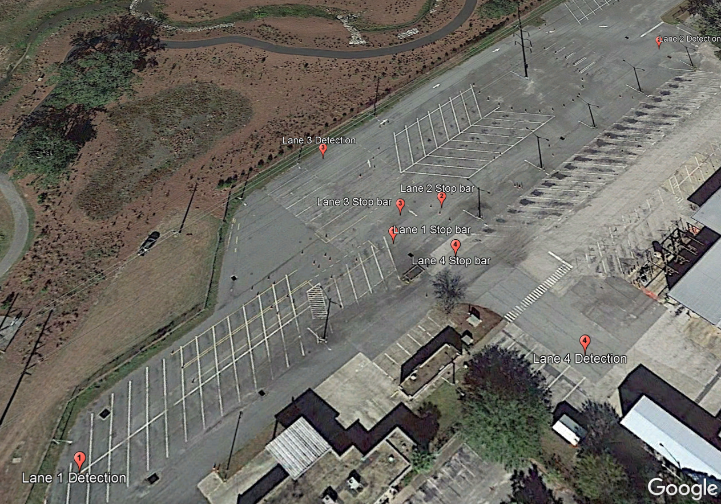

**Ash Omidvar - 2018**

**Testing Path and Signalization Scheme at Hypothetical intersection – RTS Facility**

***Φ*1**

***Φ*3**

***Φ*2**

***Φ*4**